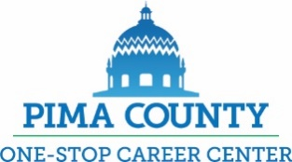
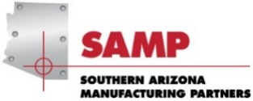
Student Timeline for 2022 SAMP Internship Program
Apprentice/Intern Timeline (check marks indicate completed)
January 27-31, 2022, announcement to students and industry – Application packets delivered to schools
Prior to April, 2022 complete FAFSA and save the email that you receive that indicates scholarships and grants available to you
March 4, 2022 - Internship application completed packets due to Kathi Finfrock, 2797 E. Ajo Way, Tucson,85713
  - Completed Student Form- Areas of interest 2022
  - Cover letter of interest addressed to Southern Arizona Manufacturing Partners
  - Current resume including: contact phone number and personal email address (other than your high school email address)
  - A referral from a teacher or career counselor (other than your Industrial Technology instructor)
  - A copy of your current H.S. transcript including: GPA and attendance record
  - A copy of your Pima Community College transcript showing dual credits obtained
  - Confirmation of completed Federal Student Aid (FAFSA)
  - Copies of all industry recognized certifications (example : NIMS, MMS or Solidworks)
  - A copy of photo ID (state ID i.e. driver’s license) – for staff files only not shared with employers prior to interviews
  - Completed Pima County One Stop WIOA SAMP checklist

March 18, 2022 - copies of applications delivered to interested SAMP partners hosting interns

April 7, 2022 - interviews at PCC Downtown Campus, Amethyst Rm. Interviews will begin at 8:30 sharp and continue until all candidates have been interviewed by all employers.
- Only companies providing interest forms will be notified to interview students.
- Only students who provide applications will be interviewed at this session.

April 15,, 2022 - students’ and employers rating sheets due to kathi.finfrock@pima.gov
Mid to late May - placements announced
May 26 – June 3 - 2022, activities for applicants to identify possible eligibility for workforce funding includes attending a scheduled One-Stop Youth Center Introduction, Intake and TABE assessment event
May 26 – June 3 - 2022 meet with SAMP intern designated case manager
June 6, 2022 - all students will attend the SAMP Symposium. 2022 session held at AGM Container, 3526 E Ft. Lowell Tucson, 85716 Employers are encouraged to arrive for lunch with your intern
June 7, 2022 - students start work assignment at Manufacturing site
June - all interns will need to finalize ALL paperwork with case manager for PCC classes to receive request for approval by One-Stop management
August 15, 2022 - PCC classes begin
ALL INTERN COMPLETED APPLICATION PACKETS ARE DUE MARCH 4, 2022
TO: Kathi Finfrock, 2797 E. Ajo Way, Tucson,85713
APPLICATION PACKETS WILL NOT BE ACCEPTED AFTER this date (3/4/22)

Please contact Kathi Finfrock 724-6742 or kathi.finfrock@pima.gov, if you have any questions/concerns

